MAT 124: Matrices review questions
- MATRICES ADDITION AND SCALAR MULTIPLICATION

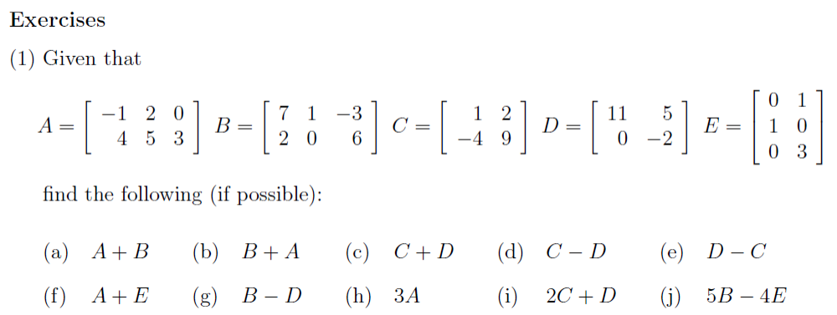

- MATRICES MULTIPLICATION

